COINS-Constantine I (306-337) AE3-Gloria Exercitvs

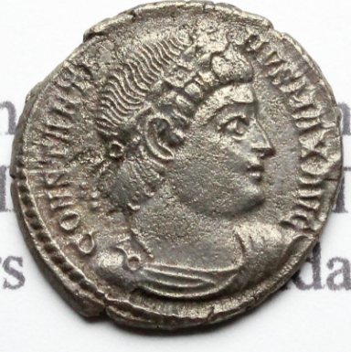 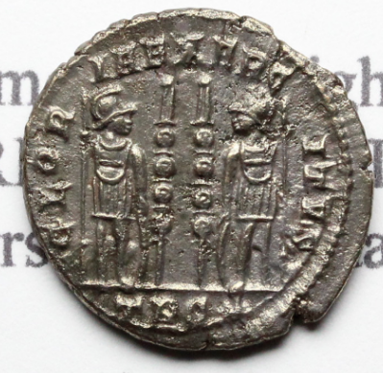

18 mm, 2.64 g